**Final Database**  
Name: Farel Arden  
Student ID: 00120190068

**Question 1:**

**1.**

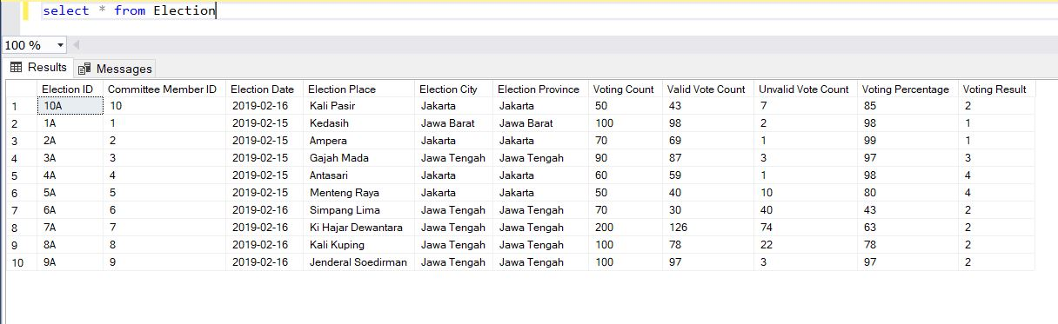

**2.**

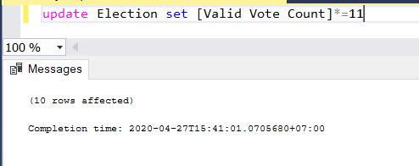

**3.**

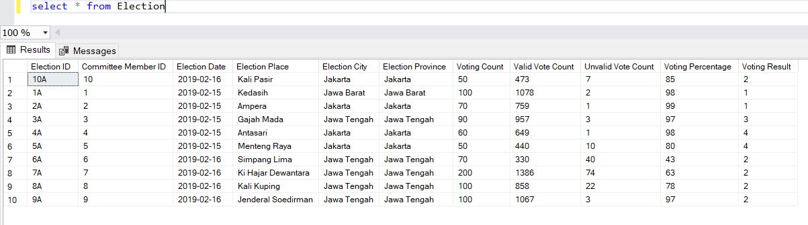

**4.**

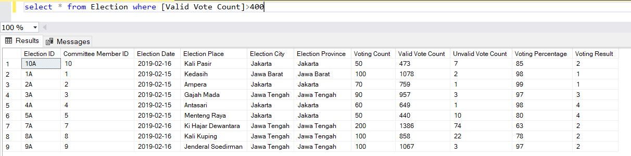

**5.**

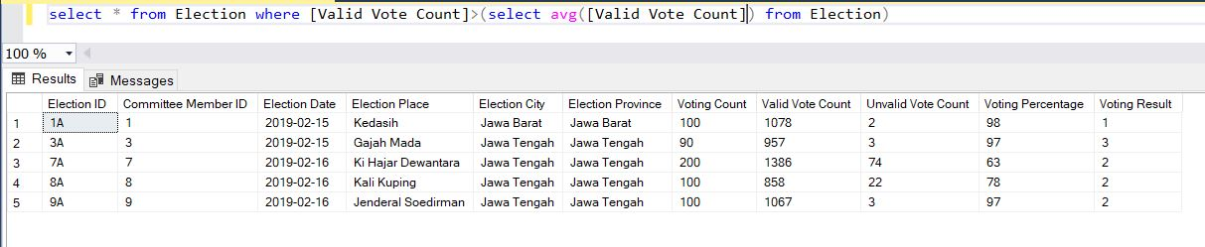

**Question 2:**

**1.**

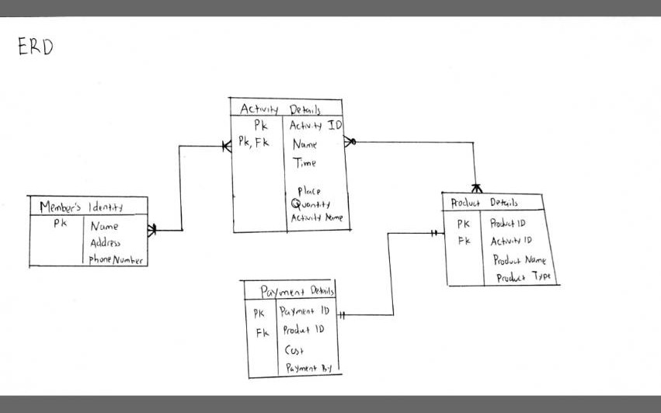

**2.**

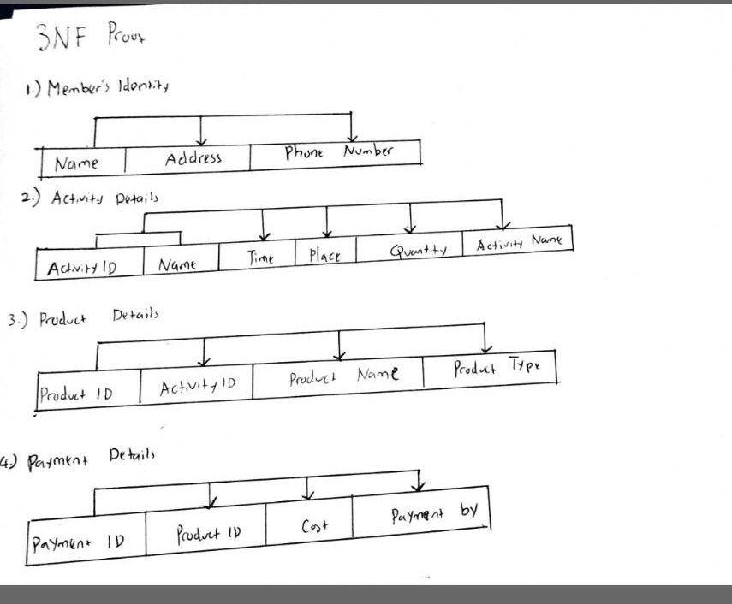

**3.**

**Entity name: Members Identity**

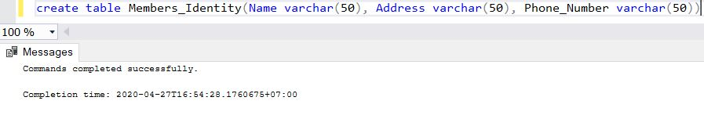

**Entity name: Activity Details**

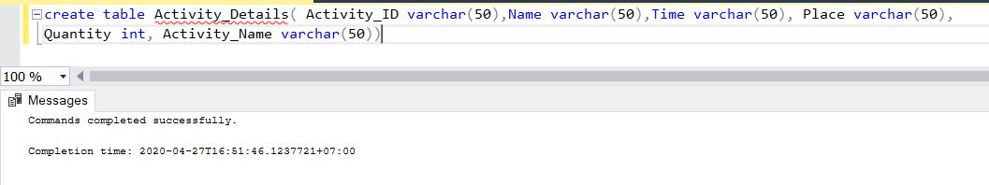

**Entity name: Product Details**

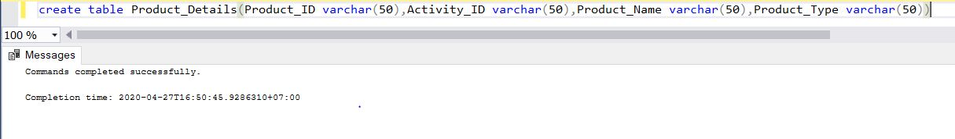

**Entity name: Payment Details**

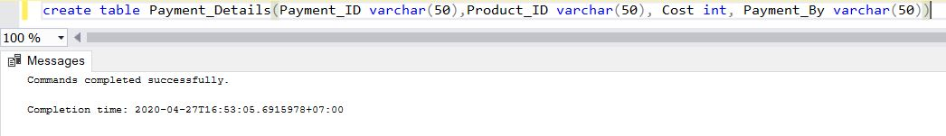

**4.**

**Entity name: Members Identity**

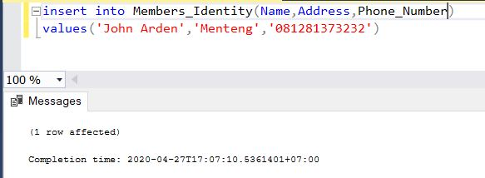

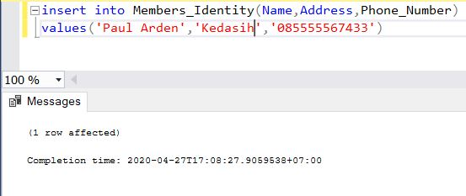

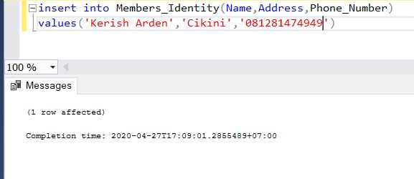

**Entity name: Activity Details**

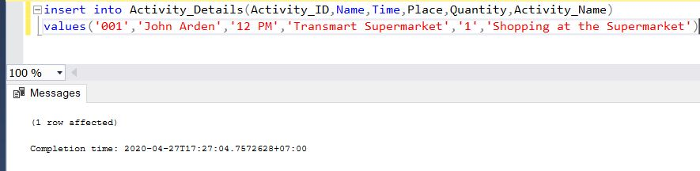

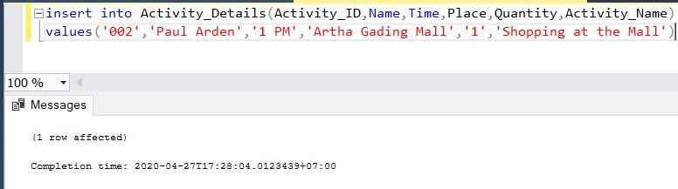

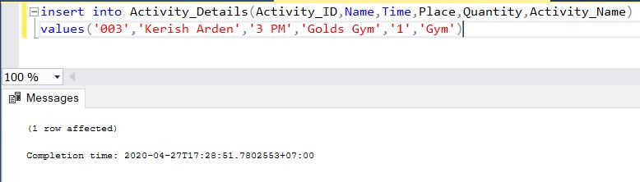

**Entity name: Product Details**

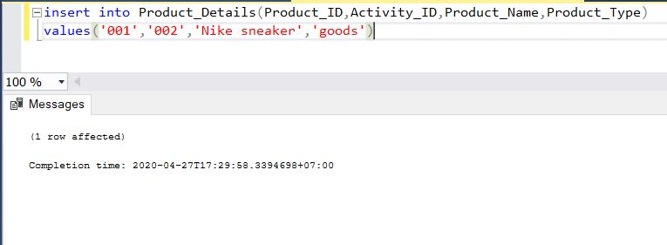

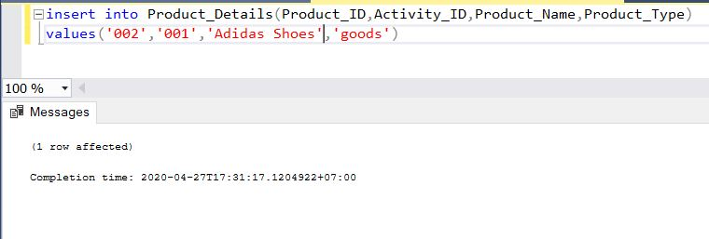

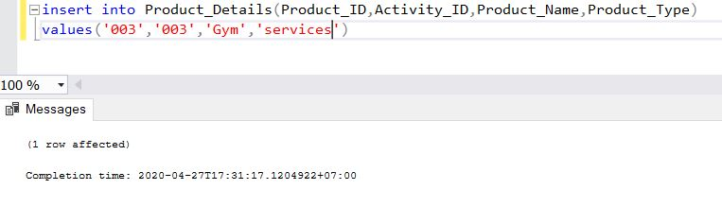

**Entity name: Payment Details**

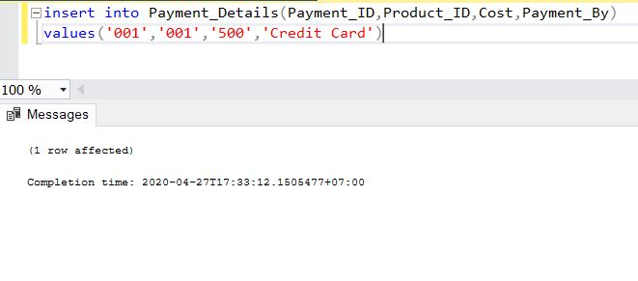

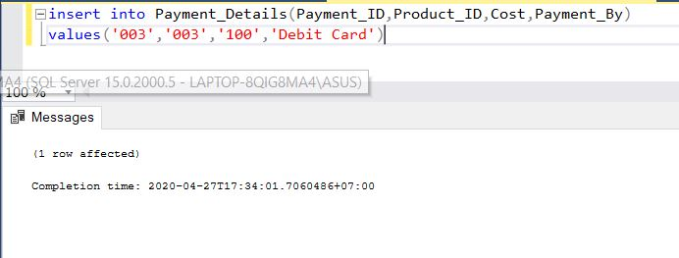

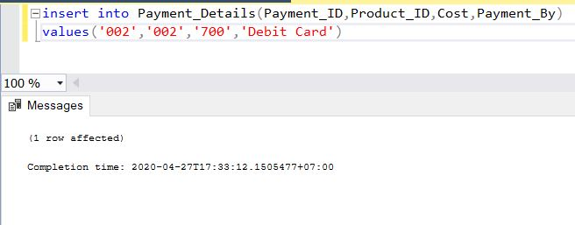

**5.**

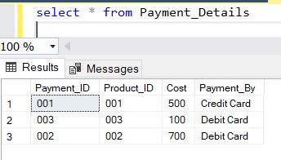

**6.**

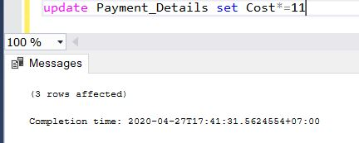

**7.**

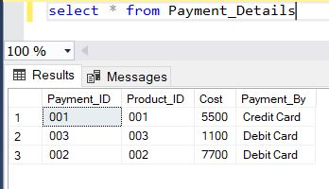

**8.**

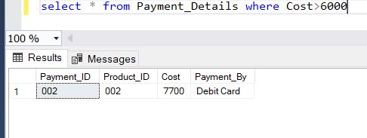

**9.**

